EXPERIMENT 2
8-Queens Problem
Question
Write a Python program to solve the 8-Queens problem.
Aim
To write a Python program to place 8 queens on an 8 × 8 chessboard such that no two queens attack each other using the Backtracking algorithm.
Algorithm
- Start with an empty chessboard.
- Place a queen in the first row.
- Check whether the position is safe.
- If the position is safe, place the queen.
- Move to the next row.
- If no safe position is available, go back to the previous row.
- Continue until all 8 queens are placed.
- Display the solution.

Code
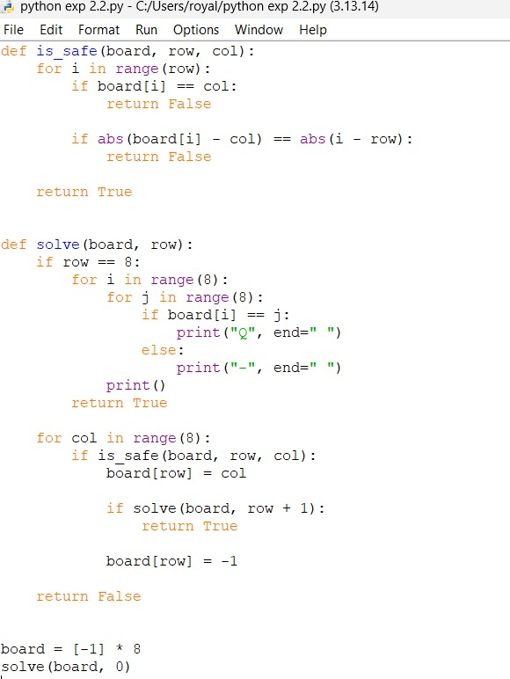

Output
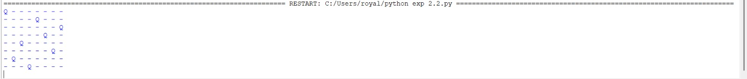
Result
Thus, the 8-Queens problem was successfully solved using Backtracking, and a valid arrangement of 8 queens was obtained.

